Ideation Phase
Define the Problem Statements

Date | 29 July 2026
Team ID
Project Name | Visualizing Housing Market Trends:An Analysis of Sale Prices and Features using Tableau
Maximum Marks | 2 Marks

Customer Problem Statement Template:
Home buyers, real estate investors, and market analysts often struggle to understand the factors that influence housing prices due to the large volume and complexity of real estate data. Existing information is scattered and difficult to interpret, making it challenging to identify market trends and make informed decisions.
The project "Visualizing Housing Market Trends: An Analysis of Sale Prices and Features using Tableau" aims to solve this problem by providing interactive visualizations and dashboards that analyze sale prices and important housing features. This solution enables users to easily explore market patterns, compare property characteristics, and gain valuable insights for better real estate decision-making.
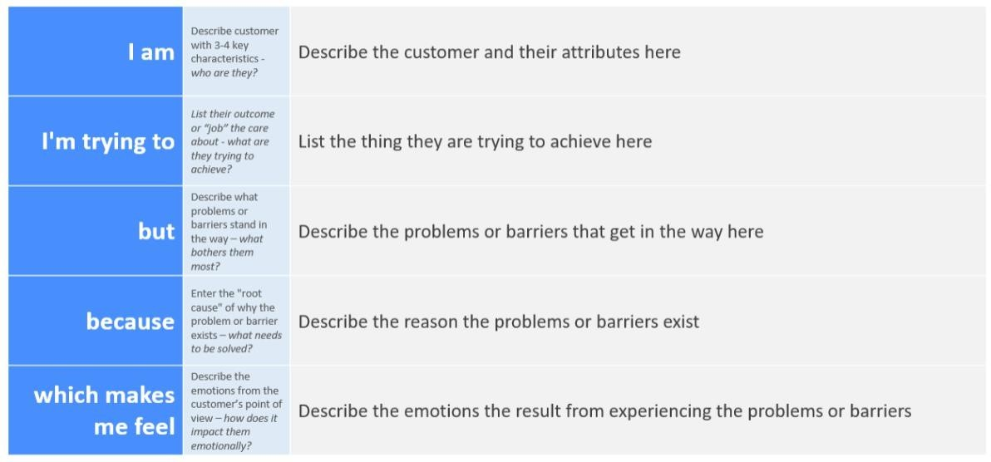

Example:
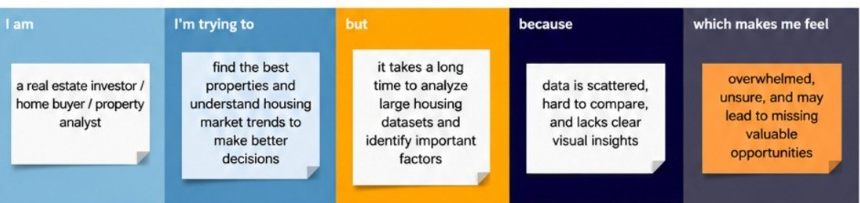

Problem  Statement (PS) | I am  (Customer) | I’m trying to | But | Because | Which makes me  feel
PS-1 | A home buyer looking for suitable properties. | Understan d housing market trends and identify properties within my budget.. | I find it difficult to analyze large amounts of housing data and compare property prices. | Housing information is scattered, and market trends are not easily understandable  . | Confused and uncertain about making the right property investment decision.
PS-2 | A real estate investor interested in market analysis. | Identify the factors that significantly influence house sale prices and market behavior. | I do not have an easy way to visualize relationships between property features and sale prices. | Traditional data reports are complex and lack interactive analysis tools. | Unsure about predicting profitable investment opportuniti es.

